

University of Ontario Institute of Technology (UOIT)

Faculty of Engineering and Applied Science (FEAS)

Department Of Electrical, Computer, And Software Engineering (ECSE)

**Operating Systems (SOFE 3950)**

Tutorial #1 Activity | Submission

Yong Deng

Winter 2020

Group Members

Aryan Kukreja (100651838)

Emil Ilnicki (100659072)

Sydney Smith (100654205)

Harasees Singh Gill (100656810)

# Conceptual Questions

## Question 1

Linux is an open-source operating system that is similar to UNIX in nature. It was created by Linus Torvalds for Intel 386 processors, and its first kernel was released in 1991. Today, it can be seen as an umbrella term for different UNIX-based operating systems available in the market from different vendors, for-profit and not-for-profit. Linux today can run on a wide variety of hardware platforms and is used as a base for building other operating systems.

Linux has many significant advantages over other competing operating systems that have made it very popular over the years. Some of these benefits include:

1. It is **open-source**. This means anyone can work on it, modify it, and distribute a modified version of it for any purpose.
2. Linux is **very reliable**, with a far lower failure count than other major operating systems (such as Windows).
3. The Linux user community is very large; hence, there is a **lot of support** available. The large active community size also results in **more frequent updates**

Linux today is used in a variety of different applications, some of which are:

|  |  |
| --- | --- |
| **Company Name** | **Purpose** |
| **Google** | The company uses Linux to power the ChromeOS that runs on its Chromebooks. Android is also built on top of the Linux OS |
| **IBM** | Many products offered by IBM run on Linux |
| **Facebook** | The servers used by Facebook run on Linux |
| **Amazon** | Amazon’s infrastructure is built on top of a customized version of Linux, similar to CentOS in nature. |

## Question 2

When software is termed to be *Free* or *Open-Source*, this means that the software comes with a license that grants the end-user the permission to study, change, and re-distribute the changed version of the software for any purpose or application.

This is significant in nature because the availability of such software encourages a diverse set of perspectives from a variety of different users from different backgrounds. Software that is purchased is mostly bought for the purpose it was designed for, and for the target market, it was designed to. Open-source software avoids this disadvantage.

Question 3

Some advantages to open source software is: that it is cheap (usually free). It is highly reliable because it is developed by talented experts and then are further worked on by tens or hundreds of people to handle issues quickly after they appear. Bugs are caught quicker as a result as well. Another advantage is that because there is no obligation to a service provider, you are not tied to particular infrastructures and hardware to match software specifications which can result in cheaper costs of business.

Some disadvantages of open source software included that it can be vulnerable to any with malicious intent. Many users may aim to make the software better by exposing bugs, but a lot of users will aim to abuse those bugs to spread infectious software, or steal information. They also may not be user-friendly since they are usually designed with a particular goal in mind and are aimed for a very particular set of use cases. Any use cases that may fall outside of that scope might not be easy to navigate for. Another downside is that they could be unsupported and thus, cannot be used. There is no one working to match the software specifically to your needs, but if you are clever enough you can do that yourself.

Question 4

Apache HTTP Server, is free and open-source cross-platform web server software, released under the terms of the Apache License 2.0.

Question 5

The three standard streams are stdin, stdout, and stderr. Stdin has a numeric value of 0, stdout has a numeric value of 1, and stderr has a numeric value of 2 just like a read, write, error system. In that sense, stdin is for reading inputs from files or external device input. Stdout is for writing information from a program to some external display (usually) or device. Stderr is used to distribute error messages and send error logs and diagnostics sent by the program.

# Application Questions

## Question 1

## 







## Question 2



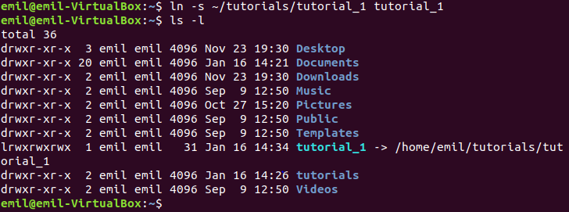

## Question 3

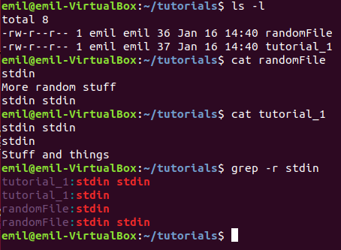

## Question 4



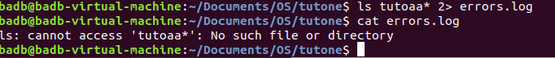

## Question 5

